

#Creating DATABASE:

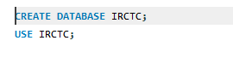

#Creating Table1:

Syntax:

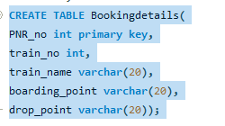

#Action Output:

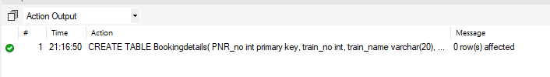

#Describe Table



#Output:

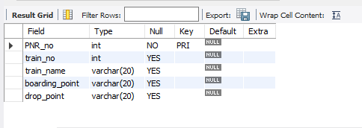

#Inserted Values:

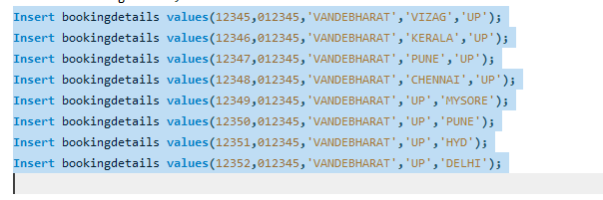

#SELECT * from bookingdetails;

#Output:

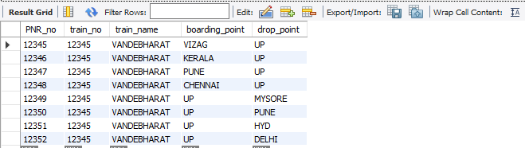

#Add Column



#Output:

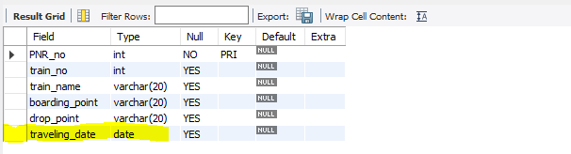

#Delete Column >> ALTER +DROP FROM DDL



#Output:

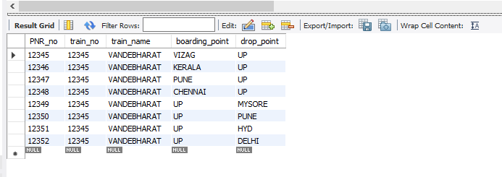

#DELETE ROW:



#Output:

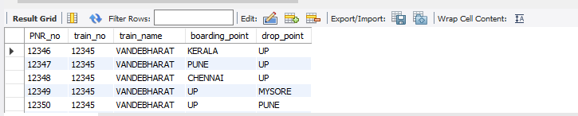

#TRUNCATE>>Deletes whole data but structure remains same



#Output:

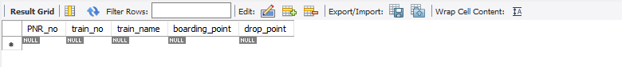

#Added extra column for pricing>>To execute Operator.

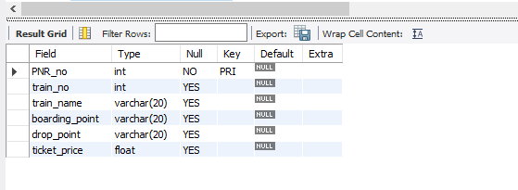

#Input: To Insert float

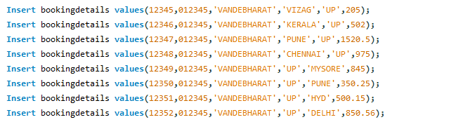

#Output:

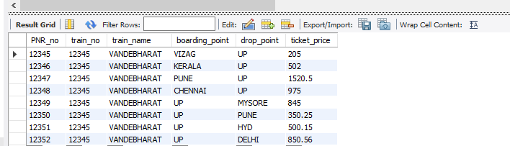

#Group by clause:

Syntax:



#Output:

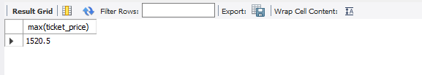

#Fetching Train number based on max price:

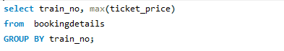

#Output:

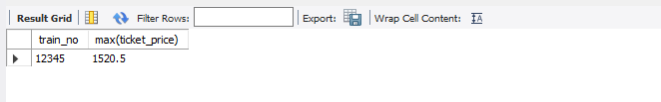

#Input: Fetching details by PNR number.

Syntax:

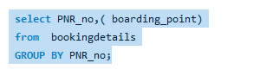

#Output:

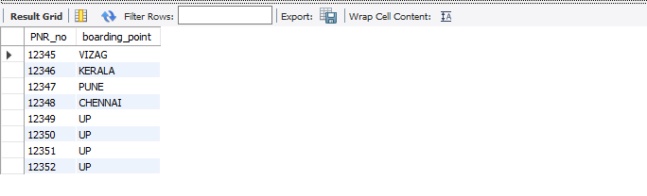

#Nested Query:

Syntax:

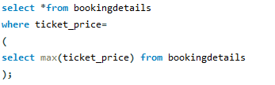

#Output:

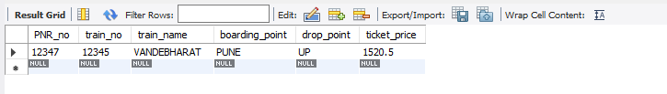

#Descending Order >>ORDER BY using LIMIT.

Syntax:

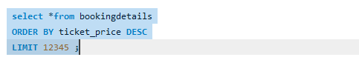

#Output:

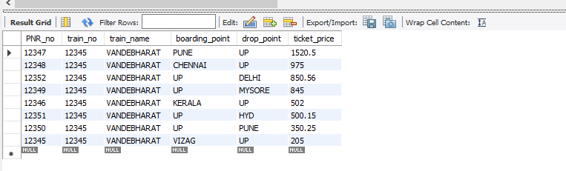

#Count:

Syntax:

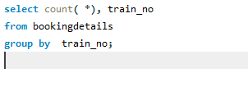

#Output:

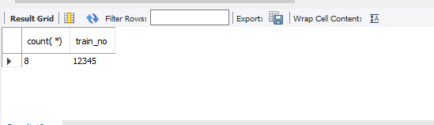

#Using USE Clause:

Syntax:

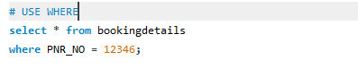

#Output:

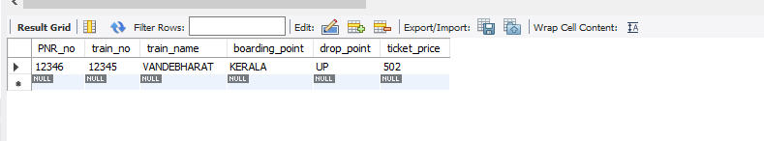

#Creating Table 2 To apply JOINS:

Syntax:

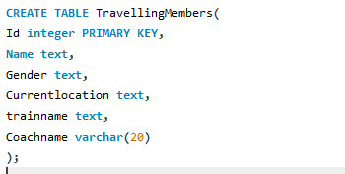

#Output:

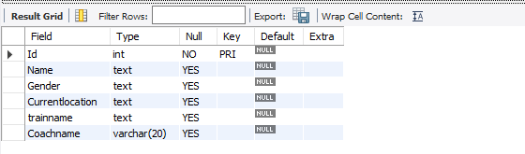

#INPUT: Inserted values into Table 2

Syntax:

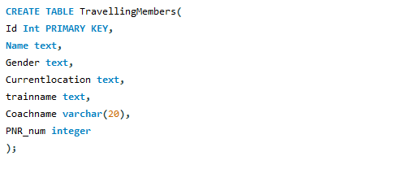

#Inserted Values:

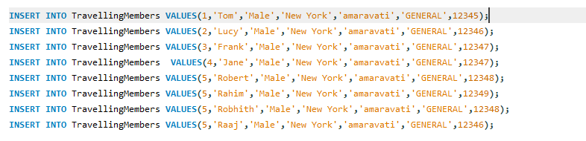

#Output:

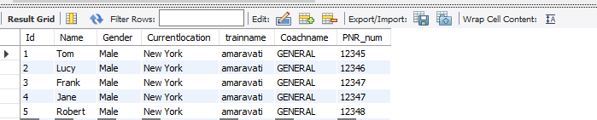

#Joining 2 tables:

Syntax:

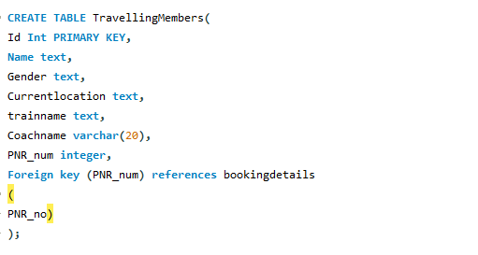

#INPUT:

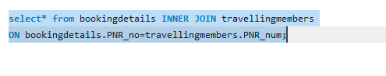

#Output:

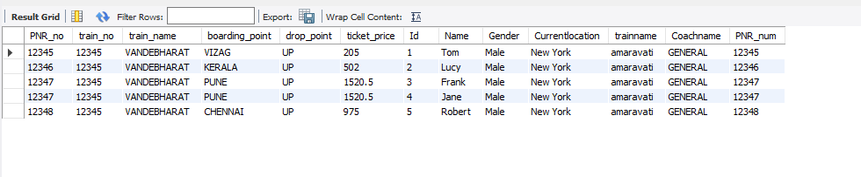

#LEFT OUTER JOIN:

#INPUT:

#Syntax:

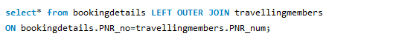

#Output:

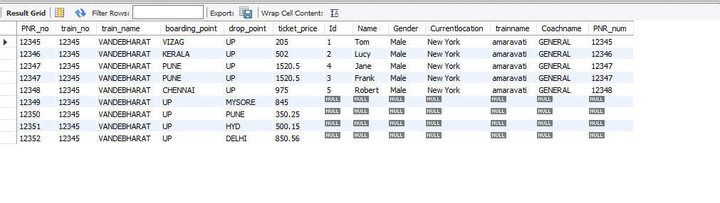

#RIGHT OUTER JOIN

Syntax:

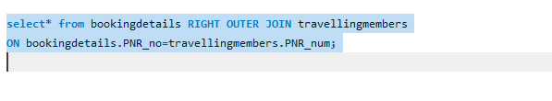

#Output:

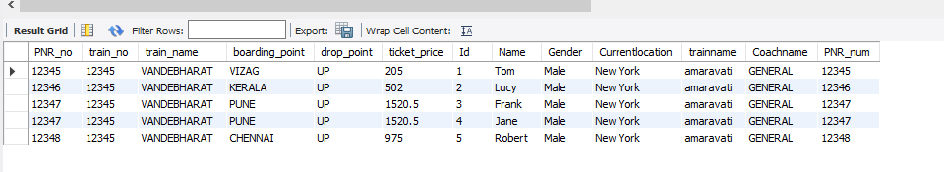

#SELF JOIN:

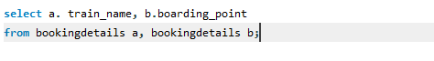

#Output:

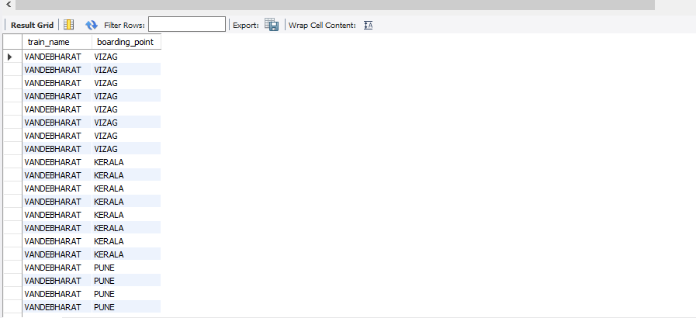

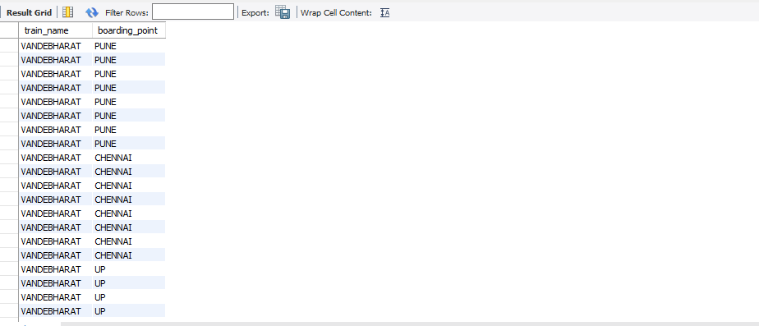

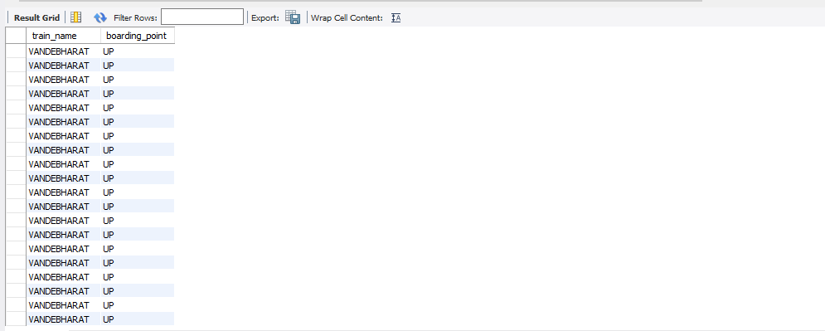

#CROSS JOIN:

Syntax:



#Output:

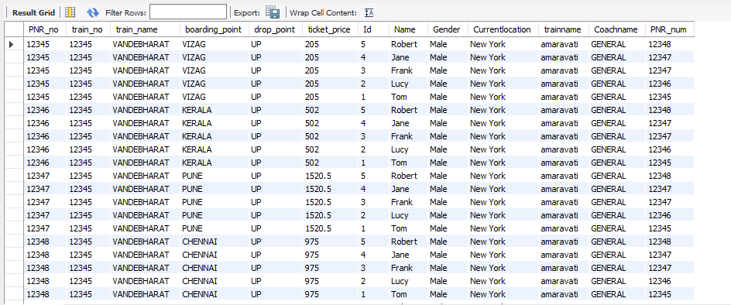

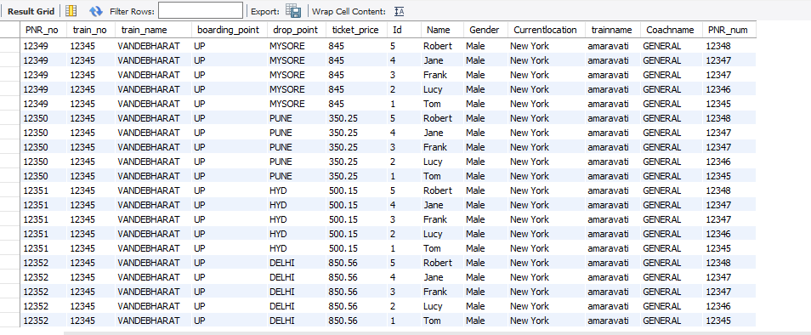

PROJECT: IRCTC

CREATED BY:

**Swamy**

**Krishnaveni**

**Rahul Dev**

**Vijay Doolinki**